**Data Fetching:** Python

**Data analysis:** SQL(MySQL ,Post Gre), R, Tableau

**ML**

**Volume**

Volume is an indicator that means the total number of shares that have been bought or sold in a specific period of time.

volume in the share market measures market activity and liquidity.

Higher volumes indicate more buyers and sellers in the market.

Within a single trading session, volumes tend to be higher during the market opening and closing as intraday traders are in a hurry to book and close their positions for the day.

When prices fall with the stock volume going high it means that the trend is going towards the downside

if the market prices are going up and the volumes are high too it means that the trend is going towards upside

**Dollar Index**

As the value of the U.S. dollar rises globally, the U.S. stock indexes tend to rise along with it.

Stock indexes tend to rise along with an increase in the value of U.S. dollar.

Companies that rely on imports thrive when U.S. dollar is strong.

Companies that sell their products globally thrive when U.S. dollar is weak.

Bond deal

News

Buy Back

Trend - Dow, Nasdaq, FTSE, SGX

Fed. ECB, RBI Policy

Beta

Indicator

Break out

Crude oil, Natural Gas (Paint, Chemicals)

Quarterly Result

**Bond Deal**

**What is a bond?**

A bond is simply a loan taken out by a company. Instead of going to a bank, the company gets the money from investors who buy its bonds. In exchange for the capital, the company pays an interest coupon, which is the annual interest rate paid on a bond expressed as a percentage of the face value. The company pays the interest at predetermined intervals (usually annually or semiannually) and returns the principal on the maturity date, ending the loan.

Unlike stocks, bonds can vary significantly based on the terms of its indenture, a legal document outlining the characteristics of the bond. Because each bond issue is different, it is important to understand the precise terms before investing. In particular, there are **six important features t**o look for when considering a bond.

1. **Maturity**

* **Short-term:** Bonds that fall into this category tend to mature within one to three years
* **Medium-term:** Maturity dates for these types of bonds are normally over ten years
* **Long-term**: These bonds generally mature over longer periods of time

1. **Secured/Unsecured Bond**
2. **Liquidation Preference**
3. **Coupon**
4. **Tax Status**
5. **Callability**

**Stock Market Exchanges in India**

**1.Bombay Stock Exchange(BSE) - Mumbai**

**BSE Limited**, also known as the **Bombay Stock Exchange** (**BSE**), is an Indian [stock exchange](https://en.wikipedia.org/wiki/Stock_exchange) which is located on [Dalal Street](https://en.wikipedia.org/wiki/Dalal_Street) in [Mumbai](https://en.wikipedia.org/wiki/Mumbai).[]](https://en.wikipedia.org/wiki/Bombay_Stock_Exchange#cite_note-bseindia.com-6)It is the oldest stock exchange in [Asia](https://en.wikipedia.org/wiki/Asia),[[7]](https://en.wikipedia.org/wiki/Bombay_Stock_Exchange#cite_note-Rawal2015-7) and also the tenth oldest in the world.[[8]](https://en.wikipedia.org/wiki/Bombay_Stock_Exchange#cite_note-8) The BSE is the [6th largest stock exchange](https://en.wikipedia.org/wiki/List_of_stock_exchanges) with an overall [market capitalisation](https://en.wikipedia.org/wiki/Market_capitalization) of more than ₹276.713 [lakh](https://en.wikipedia.org/wiki/Lakh) [crore](https://en.wikipedia.org/wiki/Crore) or US$3.56 trillion, as of January 2022

Although it has multiple indices(In [finance](https://en.wikipedia.org/wiki/Finance), a **stock index**, or **stock market index**, is an [index](https://en.wikipedia.org/wiki/Index_(economics)) that measures a [stock market](https://en.wikipedia.org/wiki/Stock_market), or a subset of the stock market, that helps [investors](https://en.wikipedia.org/wiki/Investor) compare current [stock](https://en.wikipedia.org/wiki/Stock) [price levels](https://en.wikipedia.org/wiki/Price_level) with past prices to calculate market performance), the most important is the BSE SENSEX.

**2. National Stock Exchange(NSE) - Mumbai**

National Stock Exchange of India Limited (NSE) is one of the leading [stock exchanges](https://en.wikipedia.org/wiki/Stock_exchange) in India, based in [Mumbai](https://en.wikipedia.org/wiki/Mumbai). It is the world's largest [derivatives exchange](https://en.wikipedia.org/wiki/Derivatives_exchange) by number of contracts traded[[a]](https://en.wikipedia.org/wiki/National_Stock_Exchange_of_India#cite_note-3) and the fourth largest in cash equities by number of trades[[b]](https://en.wikipedia.org/wiki/National_Stock_Exchange_of_India#cite_note-4) for the calendar year 2021. NSE is under the ownership of various financial institutions such as banks and insurance companies.[[3]](https://en.wikipedia.org/wiki/National_Stock_Exchange_of_India#cite_note-5) NSE was established in 1992 as the first [dematerialized](https://en.wikipedia.org/wiki/Dematerialization_(securities)) electronic exchange in the country and the first exchange in the country to provide a screen-based [electronic trading](https://en.wikipedia.org/wiki/Electronic_trading) system to investors.

National Stock Exchange has a total [market capitalization](https://en.wikipedia.org/wiki/Market_capitalization) of more than [US$](https://en.wikipedia.org/wiki/United_States_dollar)3.4 trillion, making it [the world's 9th-largest stock exchange](https://en.wikipedia.org/wiki/List_of_major_stock_exchanges) as of August 2021.[[2]](https://en.wikipedia.org/wiki/National_Stock_Exchange_of_India#cite_note-WFE-2) NSE's flagship index, the [NIFTY 50](https://en.wikipedia.org/wiki/NIFTY_50), a 50 stock index is used extensively by investors in [India](https://en.wikipedia.org/wiki/India) and around the world as a barometer of the Indian capital market. The [NIFTY 50](https://en.wikipedia.org/wiki/NIFTY_50) index was launched in 1996 by NSE.[[4]](https://en.wikipedia.org/wiki/National_Stock_Exchange_of_India#cite_note-6)

Unlike countries like the [United States](https://en.wikipedia.org/wiki/United_States) where nearly 70% of the country's [GDP](https://en.wikipedia.org/wiki/GDP) is derived from large companies in the [corporate](https://en.wikipedia.org/wiki/Corporate) sector, the corporate sector in India accounts for only 12–14% of the national GDP (as of October 2016). Only 7,400 companies are listed of which only 4,000 trade on the stock exchanges at [BSE](https://en.wikipedia.org/wiki/Bombay_Stock_Exchange) and NSE.

NSE also consists of multiple indices, the important ones are NIFTY 50(most imp), NIFTY 200.

What makes NSE stand out is its sectoral indices which makes us make better decisions regarding the performance of various sectors in our country. Examples are NIFTY BANK, NIFTY AUTO, NIFTY FMCG, NIFTY IT, NIFTY METAL, NIFTY PHARMA(these are the imp ones).

Another key factor in both BSE and NSE is the weightage of companies in their indices respectively, which tend to create major movements in the market, hence they are generally termed as market-movers, e.g. Adani stocks right now.

Here are the various weightages of NIFTY:-

1. **Sectoral weightage**

The NIFTY 50 Index gives a weightage of 36.81% to **Financial Services**, 14.70% to **IT**, 12.17% to **Energy**, 9.02% to **Consumer Goods**, 5.84% to **Automobiles** and 4.02% to **Metals & Mining**. The NIFTY 50 index is a free-float market capitalization index. It is important to highlight that Nifty 50 weightage of sectors keep changing according to the performance of constituent stocks.

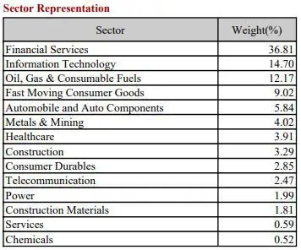

Nearly 78.5% of the NIFTY 50 is based on 5 sectors. Fin Services(mainly Banks are the heavyweights), next comes IT servicing companies like TCS, Infosys, Wipro etc. Next are the fuel-based ones e.g. Indian Oil, ONGC, BPCL etc. Next comes FMCG(Fast-moving consumer goods) companies, basically companies with our daily needs like Hindustan Unilever, Britannia, Colgate, Dabur etc. And lastly the auto companies like Tata Motors, Maruti Suzuki, Mahindra & Mahindra, etc(their importance or weightage are likely to go up as India modernises in the upcoming future).

1. **Company weightage**

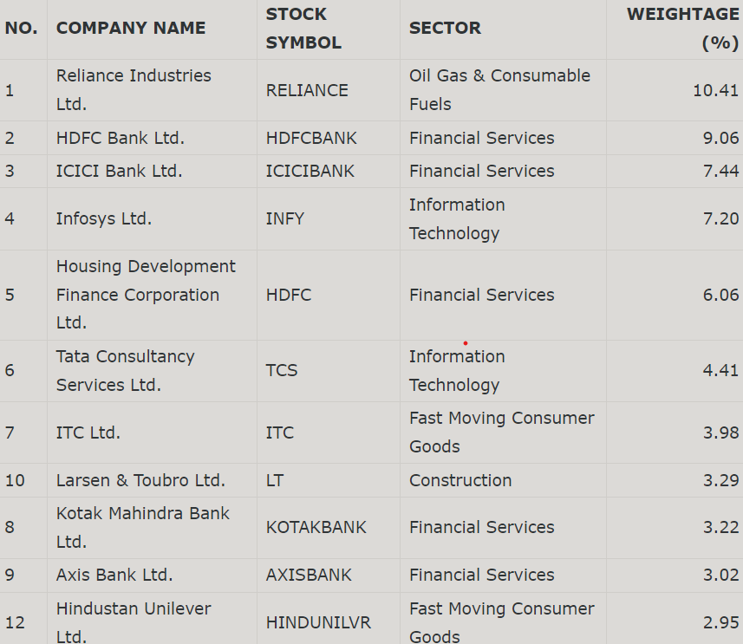

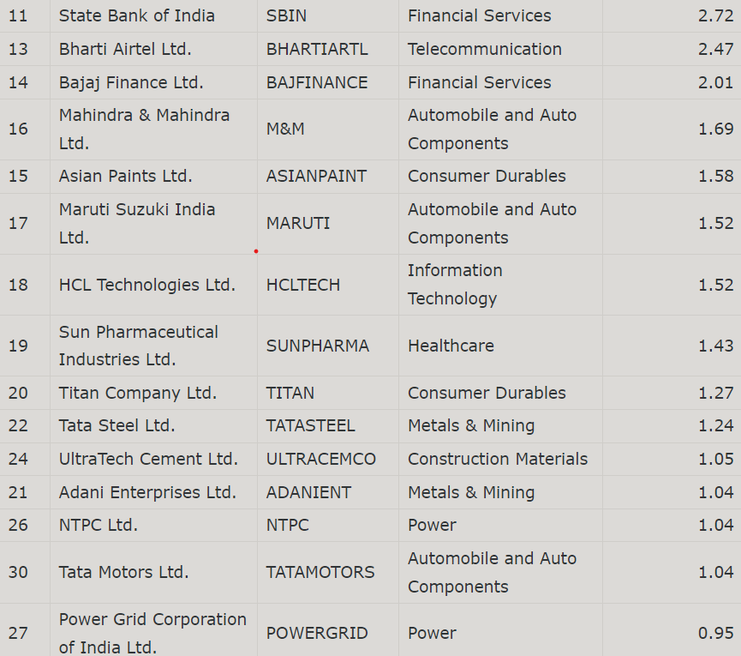

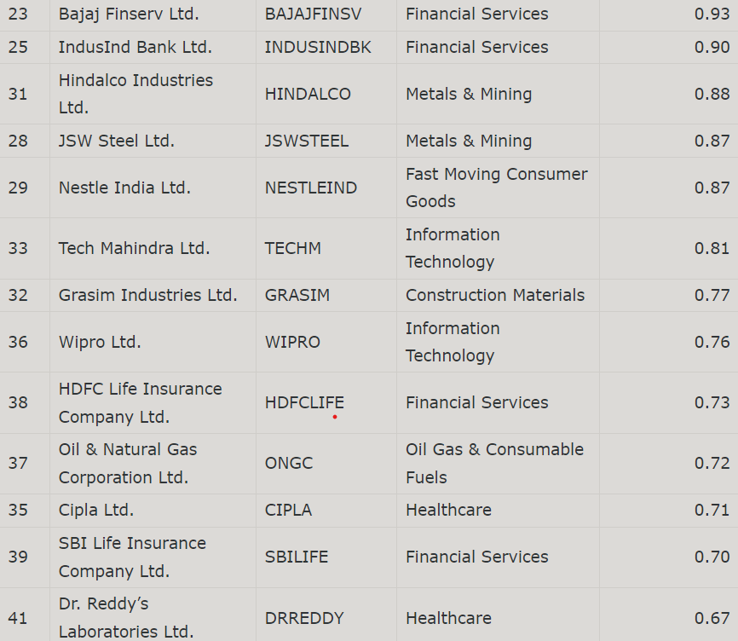

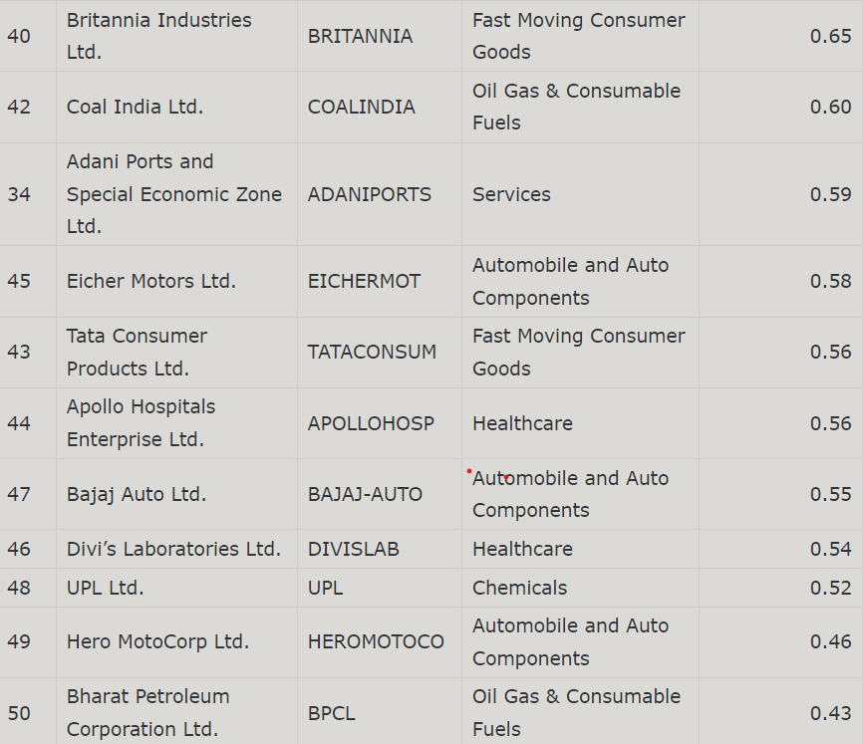

**Indicators**

1. **52 Week High/Low**

This may be the simplest technical indicator you can find.

The [52-Week](https://smartasset.com/checking-account/52-week-money-challenge) High measures the highest price that a stock has traded for in the past year. The low measures its lowest point over that same time period.

Investors use this to establish what is known as support and resistance bands. A support band is a low point, where you expect downward trading to slow down or halt. A resistance band is a high point, where you expect upward trading to slow down or halt. While simple, it’s common for investors to avoid trading significantly above a stock’s 52-Week High or below its 52-Week Low. This can give investors a way to [predict trading](https://smartasset.com/financial-advisor/trading-strategy) as they approach those points.

1. **P/E Ratio(Price to Earnings Ratio)**

**P/E=Share price/Earnings per share**

A [price-to-earnings ratio](https://smartasset.com/investing/what-is-a-good-pe-ratio) compares the stock’s share price against the underlying company’s earnings-per-share (or EPS). It measures how much you’re paying for every dollar of earnings that the company makes. **For example, say a stock has a P/E Ratio of 10. This means that if you buy a share of this stock, you’re paying $10 for every $1 of underlying earnings that share represents**.

Investors use the [P/E Ratio](https://smartasset.com/investing/what-is-price-earnings-ratio) to determine if a stock is overbought or oversold. When the ratio gets too high, it generally indicates that the stock is getting too expensive relative to the amount of value you’re getting. Investors will probably start to sell fairly soon. By contrast, a low P/E Ratio indicates that investors can get a lot of value for their money. You might expect people to begin buying.

1. **Moving Averages**

Moving average is a technical analysis tool that smooths out price data by creating a constantly updated average price. On a price chart, a moving average creates a single, flat line that effectively eliminates any variations due to random price fluctuations.

The average is taken over a specific period of time–10 days, 20 minutes, 30 weeks, or any time period the trader chooses. For investors and long-term trend followers, the 200-day, 100-day, and 50-day [simple moving average](https://www.investopedia.com/terms/s/sma.asp) are popular choices.

There are several ways to utilize the moving average. The first is to look at the angle of the moving average. If it is mostly moving horizontally for an extended amount of time, then the price isn't [trending](https://www.investopedia.com/terms/t/trend.asp), it is [ranging](https://www.investopedia.com/terms/t/tradingrange.asp). A trading range occurs when a security trades between consistent high and low prices for a period of time.

If the moving average line is angled up, an [uptrend](https://www.investopedia.com/terms/u/uptrend.asp) is underway. However, moving averages don't make predictions about the future value of a stock; they simply reveal what the price is doing, on average, over a period of time.

[Crossovers](https://www.investopedia.com/terms/c/crossover.asp) are another way to utilize moving averages. By plotting a 200-day and 50-day moving average on your chart, a [buy signal](https://www.investopedia.com/terms/b/buy-signal.asp) occurs when the 50-day crosses above the 200-day. A sell signal occurs when the 50-day drops below the 200-day.The time frames can be altered to suit your individual trading timeframe.

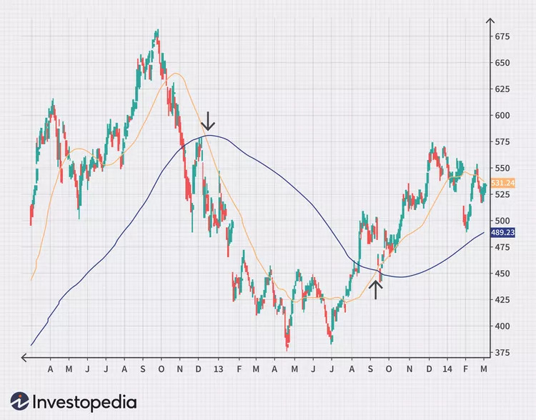

When the price crosses above a moving average, it can also be used as a buy signal, and when the price crosses below a moving average, it can be used as a sell signal.

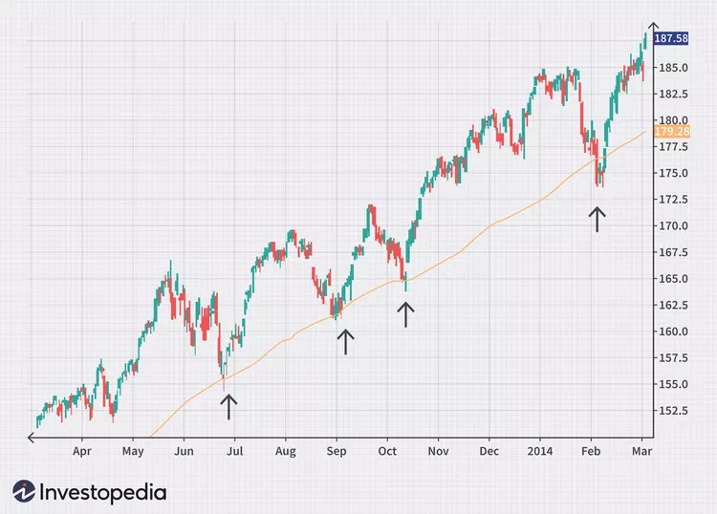

However, since the price is more volatile than the moving average, this method is prone to more [false signals](https://www.investopedia.com/terms/f/false-signal.asp), as the chart above shows.

Moving averages can also provide support or resistance to the price.1 The chart below shows a 100-day moving average acting as [support](https://www.investopedia.com/terms/s/support.asp) (i.e., the price bounces off of it).

1. **Relative Strength Index(RSI)**

The [relative strength index](https://www.investopedia.com/terms/r/rsi.asp) (RSI) has at least three major uses. The indicator moves between zero and 100, plotting recent price gains versus recent price losses. The RSI levels therefore help in gauging momentum and trend strength.

The most basic use of an RSI is as an [overbought](https://www.investopedia.com/terms/o/overbought.asp) and [oversold](https://www.investopedia.com/terms/o/oversold.asp) indicator. When RSI moves above 70, the asset is considered overbought and could decline. When the RSI is below 30, the asset is oversold and could rally. However, making this assumption is dangerous; therefore, some traders wait for the indicator to rise above 70 and then drop below before selling, or drop below 30 and then rise back above before buying.

Divergence is another use of the RSI. When the indicator is moving in a different direction than the price, it shows that the current price trend is weakening and could soon reverse.

A third use for the RSI is support and resistance levels. During uptrends, a stock will often hold above the 30 level and frequently reach 70 or above. When a stock is in a downtrend, the RSI will typically hold below 70 and frequently reach 30 or below.

